Template for Evidence(s)
UI GreenMetric Questionnaire

University : Sakon Nakhon Rajabhat
Country : Sakon Nakhon
Web Address : https://www.snru.ac.th
[2] Energy and Climate Change (EC)

[2.1] Energy Efficient Appliances Usage

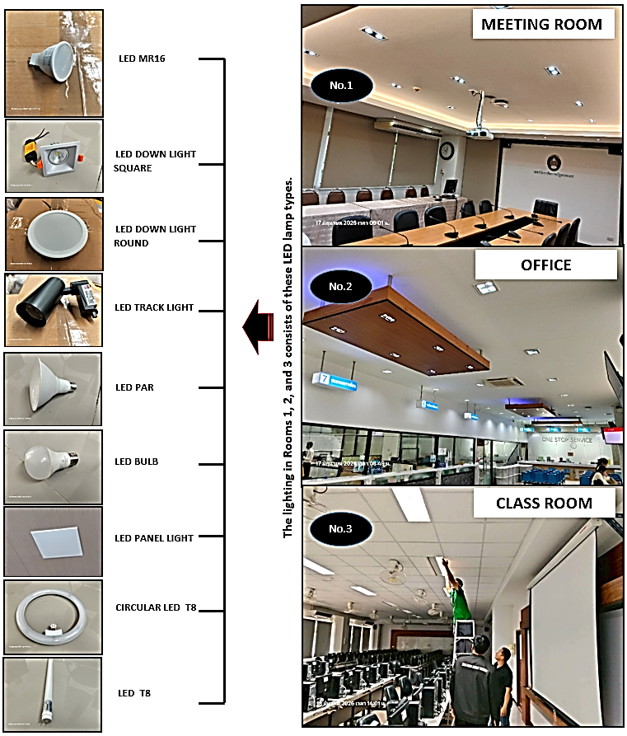 | 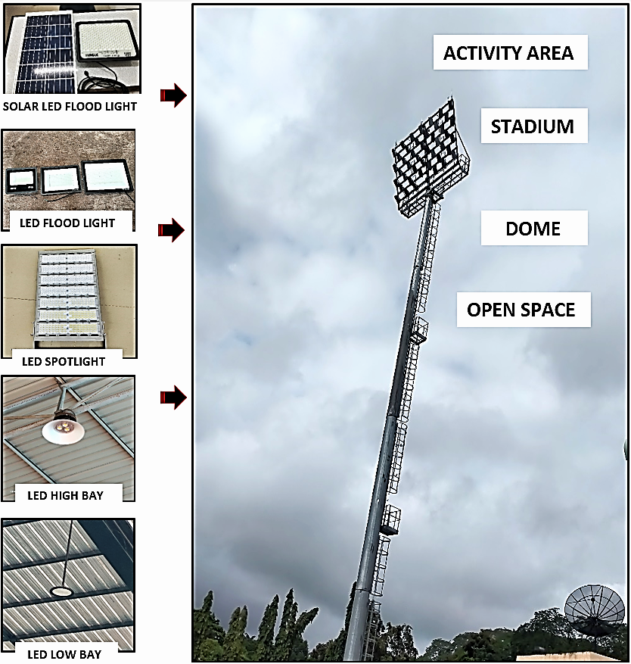
Picture 1  Examples of lamp types currently used in meeting rooms, offices, and classrooms. | Picture 2  Examples of lamp types currently used in activity area, stadium,dome and open space.

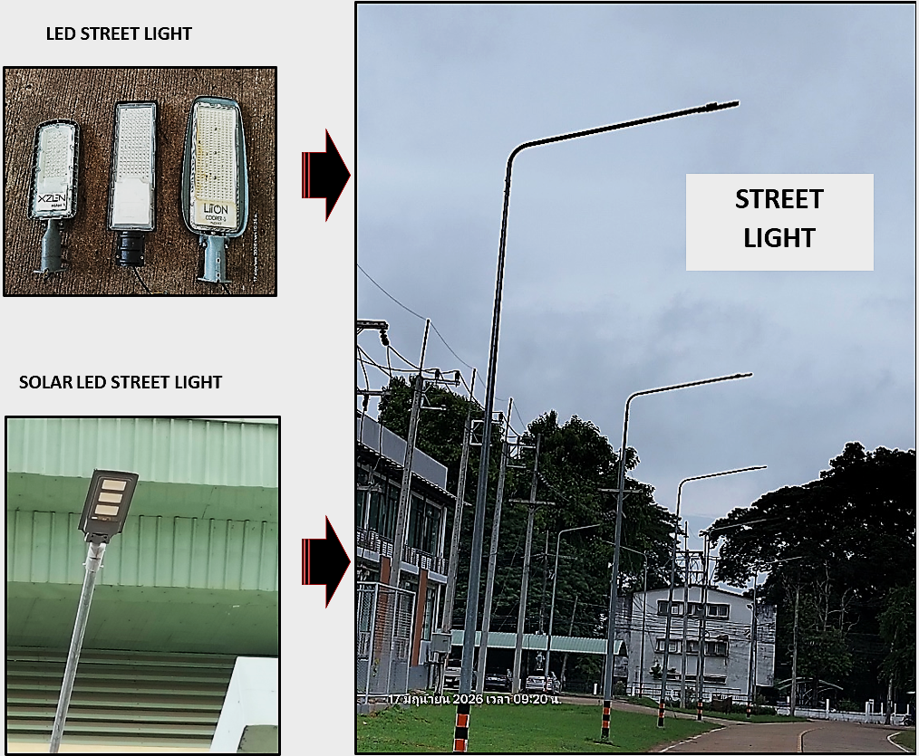

Picture 3
Examples of lamp types currently used in Street Light.

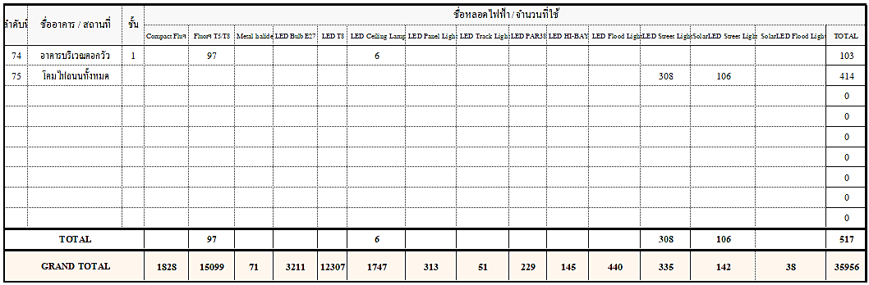

Picture 4
Examples of lamp types and the total number of lamps currently used across the university.

Description: Comparison of Energy-Efficient and Conventional Electrical Equipment Used at the University

Appliance | Total Number | Total number energy Efficient appliances | Percentage
LED Lamp | 35,956 | 18,958 | 52.725 %
Etc. | … | … | …
 |  | Average Percentage | 52.725 %

Additional information : The university places great importance on reducing energy consumption and promoting sustainable operations. To achieve this, conventional lighting has been gradually replaced with LED lamps in classrooms, meeting rooms, laboratories, and offices across the campus. LED lighting is highly energy-efficient, consumes less electricity than conventional lamps, and has a longer lifespan. As a result, it helps reduce electricity consumption, lower energy costs, and decrease greenhouse gas emissions associated with electricity use. This initiative is part of the university’s commitment to efficient resource management and supports its long-term sustainable development goals.

